# Reaction Spontaneity (Quick Method)

A **spontaneous reaction** is a one that occurs under its current conditions without intervention.

The following is a simplified method can be used to predict redox reaction spontaneity using the reduction potential tables.

* The strongest oxidising agent in the cell will react with the strongest reducing agent.
* A reduction reaction will occur in the half-cell with the higher E∘ value (goes right), whereas an oxidation reaction will occur in the half-cell with the lower E∘ value (goes left).

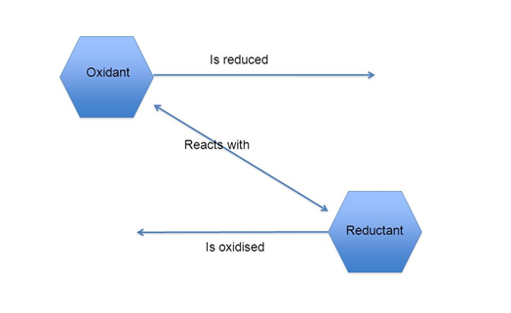

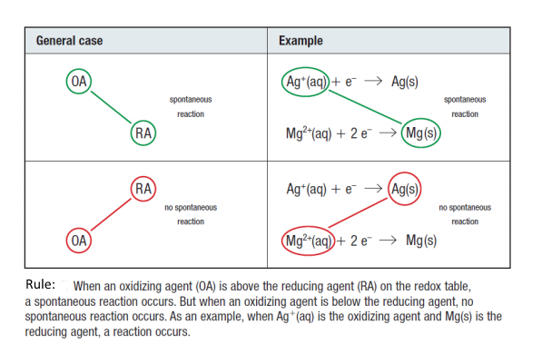

In order for a redox reaction to be spontaneous, the oxidizing agent must be strong enough to take electrons away from the reducing agent. Therefore:

***The oxidising agent must be higher on the redox potential tables than the reducing agent***

# Reaction Spontaneity (using cell potentials)

Eo(cell) = Eo(reduction)+ Eo(oxidation)



Energy is required to make electrons move through a circuit. This energy is provided by the electromotive force (EMF)

* If the EMF is positive, redox reaction is spontaneous
* If the EMF is negative, redox reaction is not spontaneous, the reverse direction would be spontaneous
* If the EMFis zero, the reaction is at equilibrium.

**For Example:**

Would chlorine react with a sodium bromide solution?

Cl2(g) + 2Br- (aq) 🡪 2Cl-(aq) + Br2 (g)

Cl2(g) +2e- 🡪 2Cl-(aq) Eo(red)= +1.36V

2Br- (aq) 🡪 Br2 (g) +2e- Eo (oxid)= -1.07V

EMF = 1.36 + (-1.07)

= 0.29V

Yes (EMF is +ve, the reaction is spontaneous and will progress to the right.)

Does copper react with dilute hydrochloric acid?

Cu(s) + 2H+(aq) 🡪 Cu2+(aq) +H2(g)

Cu(s) 🡪 Cu2+(aq) + 2e- Eo(oxid)= -0.34V

2H+(aq) + 2e- 🡪 H2(g) Eo(red)= 0.00V

EMF = -0.34 +0.00

= -0.34V

No (EMF is –ve, the reaction is not spontaneous, it will not progress to the right.)

A strip of magnesium metal is placed in an aqueous 1M zinc sulphate solution. Will a spontaneous redox reaction occur?

Mg(s) +Zn2+(aq) 🡪 Mg2+(aq) + Zn(s)

Mg(s) 🡪 Mg2+(aq) + 2e- Eo(oxid)= +2.37V

Zn2+(aq) + 2e- 🡪 Zn(s) Eo(red)= -0.76V

EMF = 2.37 + (-0.76)

= 1.61V

Yes (EMF is +ve, the reaction is spontaneous and will progress to the right.)